Master thesis project: Multivariate statistical analysis on waste incineration process
- Starting: February 2018
- Supervisor: Juan Juan CAI (j.j.cai@tudelft.nl)
A big challenge for waste-to-energy plants is that the waste boilers suffer from the corrosion of critical component such as the refractory anchors and degradation of refractory materials due to process conditions. To predict and thus to prevent such damages, it is necessary to understand the interaction of various key components undergoing inside the boilers. Over the waste incineration process, different types of boilers are used at different stages of the process. The student will be working on the data descripting the following key components for the boilers.
- (extremely high) temperature at various places
- gas composition in several parts of the boilers
- air pressure
- reduction or oxidation environment conditions in different areas
- development of corrosion in different areas
The student will be analysing laboratory data as well as plant data. Laboratory data are measured from test boilers (Figure 1) which is built in laboratory at Energy research Centre of the Netherlands (ECN) at Petten, while plant data are measured in the boilers that are in use for waste incineration. It is worthy to mention that it will be the first time that data of such type are collected in The Netherlands. Moreover, the focus on the integral processes is rather new in this type of research.
Figure 1 Test boiler at ECN Petten

The student will use statistical toolkit (among others dependence analysis, causation analysis, regression, and time series) to analyse the data and to unveil (partially) the dynamics inside the boilers.
This project will be carried out in the company of Gouda Vuurvast Services. The student will work closely with colleagues from the companies. The obtained result is expected to provide insight on the further progress on the corrosion problem and as an input for the development of the dynamic simulation model in the ‘de lerende steen’ project (see more in the background information)
  - Background information
Gouda Vuurvast Services

The refractory materials in waste incinerators, oil crackers, gasifiers and melting furnaces should not just be built, but also has to be refurbished and maintained. Gounda Vuurvast Services is specilized in all related works, ranging from complete projects, breakdown reparation, and maintenance to a one day’s job. A network of out-reaching service workers spread across the country ensures short distance accessibility and quick response. An important added-value that Gouda Vuurvast Services delivers to its customer is to provide customer specific solutions through out-of-box thinking on installation work.

Waste Incineration Plants (WIPs)

In the Netherlands, most of the residual waste from the household and other recyclable waste are burned in waste incineration plants (WIPs, Figure 2). In these wastes, there are biomass such as papers and food residues. There is no other way to treat these kind of waste. The energy that comes out of the treatment is noticed as renewable energy. According to the waste statistics, around 7.6 million ton waste is burned in the Netherlands, and around 56% of recovered energy is produced from biomass.

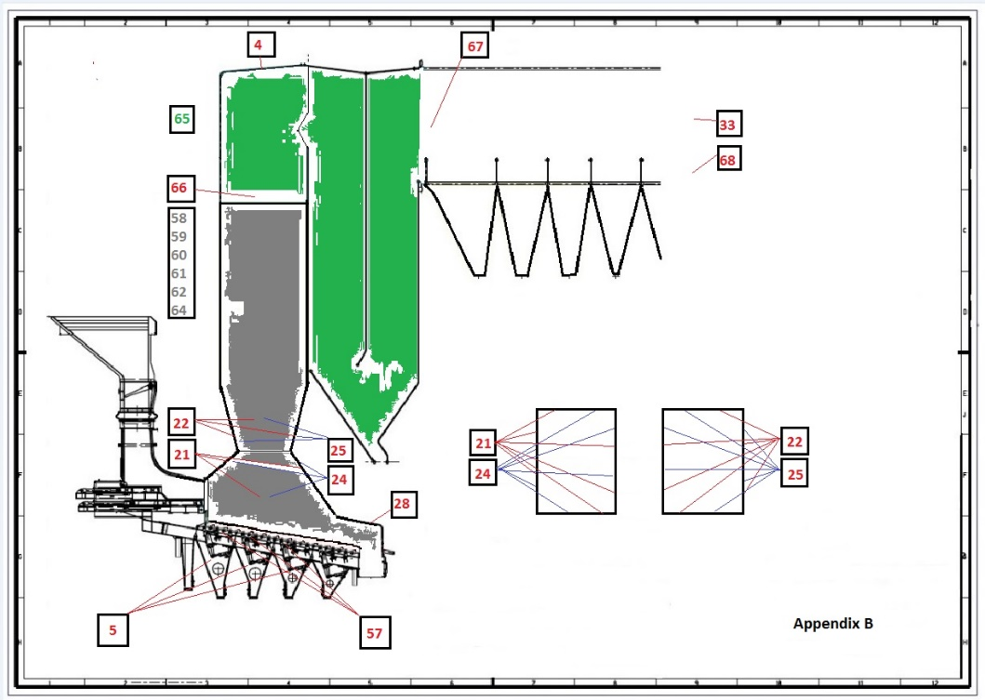
Figure 2 Design diagram of WIP

Residue waste is burned in large WIPs. And energy regain is important process of WIPs. WIPs regain average around 20% of the energy from the waste as electricity and 23% as heat. There are many opportunities in the area of heat utilization, however, it depends greatly on the locations of the plants. The heat produced through the burning process in waste incinerators can be used to generate electricity through steam turbine, deliver steam to industry, and provide heating to municipality. An incineration system is needed to transfer the heat from the combustion process to membrane walls in the boiler. On the one hand, the membrane walls are protected with refractory materials against the aggressive conditions. On the other hand, it helps to achieve optimal heat transfer.

“De Lerende steen” project

In the project new products, measurements, methods and process techniques are developed and tested, to help in achieving optimal and sustainable incineration processes in the WIPs. One work package of the project is to develop a dynamic simulation model. The model is a multidisciplinary scaling up of the existing Computational Fluid Dynamics (CFD) models, with which research has been done in large incinerators. The new dynamic simulation model contributes to the existing knowledge base by taking account many new elements/parameters namely: heat process, gas composition (e.g. CO, CO₂, NO_{X}), energy production, corrosion, damage to refractory material and slag formation. The model enables the prediction of the expected damage in the incineration process, thus provides insight for improvement in maintenance.

