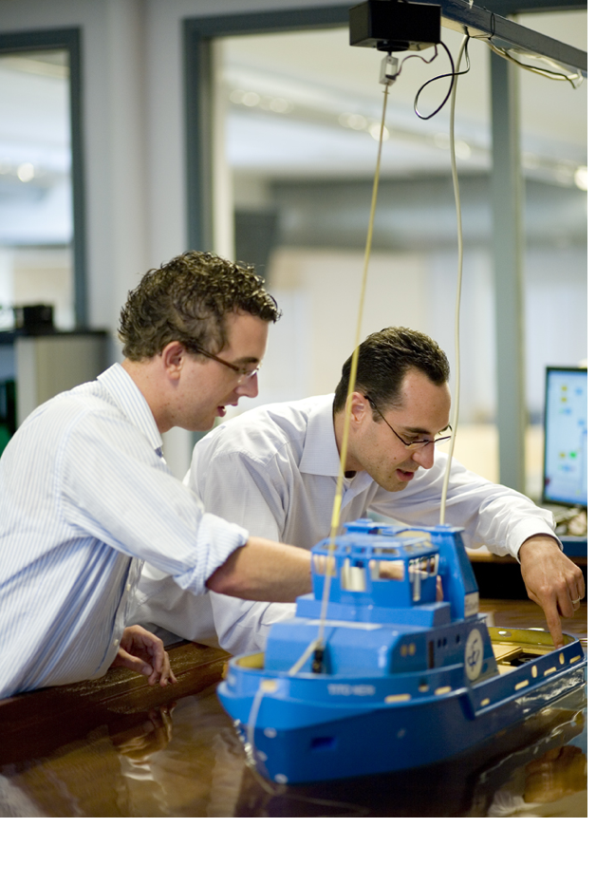

<Your Name>

Travel Report

<University name, country>

<Academic year>

1 Introduction

# General Information

Period Abroad <start date – end date>

Programme <Minor/Master>

At TU Delft <Mechanical Engineering, Technical Medicine,…>

Rating University <Number between 1 and 5>/5

Rating exchange in general <Number between 1 and 5>/5

Can future exchange students contact you? <Yes/No. If yes, include telephone number/email adress>

Useful links <Which internet links where useful? E.g. for selecting courses, public transport, assistance for internationals,…>

<*All information between <> brackets has to be filled in, with the brackets removed. You don’t have to answer all the questions if you think the information is not relevant, other useful information can of course also be written. Also the cover picture has to be replaced, and pictures can be added to fill in the blank spots in the report.*

Briefly introduce yourself. Why did you go abroad? Did you enjoy your stay? What did you mostly do during free time? Would you recommend this university to other exchange students? *100 to 200 words*

# Opinion

# Education

<What was the quality of the lectures, were the courses well taught? Is language an issue? Are the courses harder/easier than in Delft? How is the study load compared to Delft? How is the support for international students? *Feel free to use sub headers like ‘English level’, or ‘Study load’* >

# Free time

<How is the culture? What did you do during free time? Did you travel? Where did you meet new friends? *Feel free to use sub headers like ‘Travelling’, ‘Culture’, etc. >*

# Practicalities

# Preparations

<What did you need to do in advance for your exchange period? What paperwork is required by the host university? Did you need a visa? Any difficulties getting a visa? Other preparations?>

# Housing

<Is housing provided/assisted by the host university? In what sort of accommodation did you stay during your exchange abroad? How did you get it? How was the location? >

# Course selection

<Which courses did you take? Could you follow the courses that you initially selected? What courses would you recommended or discommend? Any problems with your schedule?>

# Expenses

<Did you receive money from a fund/scholarship? Was your exchange more/less expensive than expected? Fill in the table below. More rows can be added if necessary. >

|  |  |  |  |
| --- | --- | --- | --- |
| ***Monthly expenses*** | ***€*** | ***One-time expenses*** | *€* |
| Accommodation |  | Flights |  |
| Food |  | Visa |  |
| Insurance |  | Registration |  |
| Transportation |  |  |  |
| Entertainment |  |  |  |
| other |  | Other |  |
| *Total* |  | *Total* |  |

# Others

<Do you have others tips that you want to share with upcoming exchange students regarding your exchange experience?>