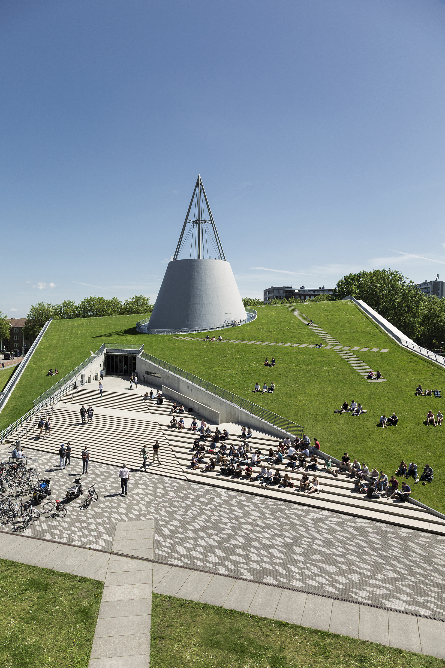

Civil Engineering and Geosciences
Exchange courses
Academic year 2023-2024

Course selection guidelines

The table below shows how the academic year is divided and what is expected of you from each semester and/or period. With the details below of how many EC you are expected to obtain, you will be able to make a study plan that will need to be approved by your home university and TU Delft.
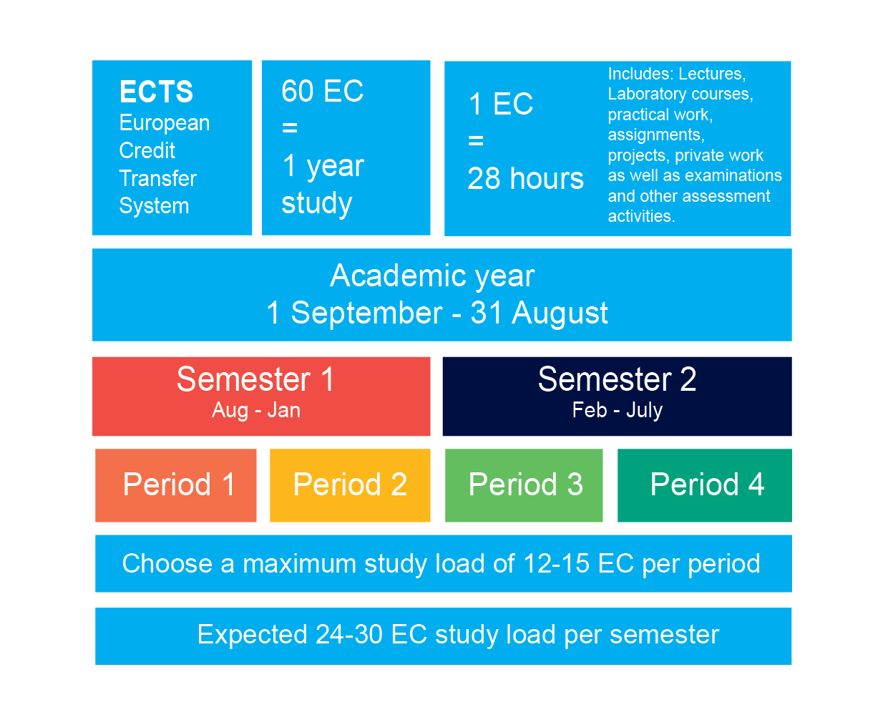
Things to consider when you choose your courses
- Will you be staying for 1 or 2 semesters? This will affect the number of EC you need to choose.
- You must take a course load equal to 24-30 EC per semester, 12-15 EC per period.
- Most courses should be chosen at the faculty where you are nominated for as student.
- More detailed information about the courses can be found via the study guide. Guidelines on how to use it can be found here.
- Are you a BSc or MSc student? Not all BSc courses are taught in English and there are specific requirements to follow MSc courses.
- Changes to your course plan after your arrival still need to meet the above requirements.
- Carefully consider your course workload (minimum 24 EC), and the manageability of it. Students are not permitted to re-sit exams after the end of the official exchange period. Alternative course/s will need to be taken at your home university when you return.
- Within the study programme, the Faculty of Civil Engineering and Geosciences offers fixed course packages for incoming students. These are the recommended module packages, divided per semester and per master programme. If you want a modified package, it is negotiable.
- Students have the responsibility to check if they meet all prerequisites.
Civil Engineering and Geosciences
Courses for 2023
Important information
Within the study programme, the Faculty of Civil Engineering and Geosciences offers fixed course packages for incoming students. These are the recommended module packages, divided per semester and per master programme.
If you want a modified package, it is negotiable.

The offered courses and modules are divided over the Fall and Spring semester.
All module and course descriptions can be found on our TU Delft study guide.
Students have the responsibility to check if they meet all prerequisites.

Fall semester (September-February)

Master Civil Engineering (1st year)
Course code | Course name | Cat. | Ec. | Period (Q)
CEGM1000 | Modelling, Uncertainty and Data for Engineers | MSc | 12 | Q1, Q2
CIEM0000 | Mechanics and Interdisciplinary Perspectives | MSc | 9 | Q1

Master Civil Engineering (2nd year)
Important note: These courses will only be offered if there are enough enrolments
Course code | Course name | Cat. | Ec. | Period (Q)
CIEM1301 | Advanced Computational Mechanics | MSc | 5 | Q1
CIEM1302 | Forensic Construction Materials Engineering | MSc | 5 | Q1
CIEM1303 | Upscaling Techniques in Construction Materials Design and Engineering | MSc | 5 | Q1
CIEM1304 | Glass Science and Engineering | MSc | 5 | Q1
CIEM2301 | Offshore Geotechnical Engineering | MSc | 5 | Q1
CIEM2302 | Trenchless Technologies | MSc | 5 | Q1
CIEM2303 | Rock Mechanics Applications | MSc | 5 | Q1
CIEM2304 | Environmental and Energy Geotechnics | MSc | 5 | Q1
CIEM3301 | Building with Nature | MSc | 5 | Q1
CIEM3302 | Dredging | MSc | 5 | Q1
CIEM3303 | Advanced modelling of turbulent flows and transport | MSc | 5 | Q1
CIEM3304 | Physical Oceanography | MSc | 5 | Q1
CIEM4301 | Onshore Hydropower | MSc | 5 | Q1
CIEM4302 | Cold Regions Engineering | MSc | 5 | Q1
CIEM4303 | Flood Risk | MSc | 5 | Q1
CIEM4304 | Hydraulics Fieldwork | MSc | 5 | Q1
CIEM5301 | Shell Structures | MSc | 5 | Q1
CIEM5303 | Wave Mechanics of Structures | MSc | 5 | Q1
CIEM5304 | CO2 Neutral Structures | MSc | 5 | Q1
CIEM5305 | Fire Safety Design | MSc | 5 | Q1
CIEM5306 | Assessment of Existing Concrete Structures | MSc | 5 | Q1
CIEM5307 | Forensic Structural Engineering | MSc | 5 | Q1
CIEM5308 | Parametric Design and Digital Fabrication | MSc | 5 | Q1
CIEM5309 | Advanced Building Physics | MSc | 5 | Q1
CIEM5310 | Contact and Interface Mechanics for Engineering Structures | MSc | 5 | Q1
CIEM5311 | Transportation Infrastructure under Extreme Conditions | MSc | 5 | Q1
CIEM5312 | Emerging Technologies for Transportation Infrastructure | MSc | 5 | Q1
CIEM6301 | Railway Traffic Management | MSc | 5 | Q1
CIEM6302 | Advanced Data Science for Traffic and Transportation | MSc | 5 | Q1
CIEM6303 | Transitions, Sustainability & Innovation | MSc | 5 | Q1
CIEM6304 | eXtended Reality (XR) for Civil Engineering | MSc | 5 | Q1
CEGM2000 | Suspension, Sludge and Soil | MSc | 10 | Q2
CEGM2001 | Sustainable Cities | MSc | 10 | Q2
CEGM2002 | Engineering for Global Development | MSc | 10 | Q2
CEGM2003 | Data Science and Artificial Intelligence for Engineers | MSc | 10 | Q2
CEGM2004 | Noise and Vibration: Generation, Propagation and Effect on Humans and Environment | MSc | 10 | Q2
CEGM2005 | Advanced Topics in Probability and Statistics in Engineering | MSc | 10 | Q2
CEGM2006 | Subsurface Storage: Energy and Climate | MSc | 10 | Q2
CEGM2007 | Resilient Deltas under Climate Change; Delta Technology | MSc | 10 | Q2
CEGM2008 | Monitoring of Structural Health and Geohazards | MSc | 10 | Q2
CEGM0210 | Engineering Management Systems | MSc | 10 | Q2

Master Applied Earth Sciences (2nd year)
We offer three fixed course packages in our Master programme for incoming exchange students, in which you can combine electives in the first quarter with a cross-over module in the second quarter.
The cross-over modules will only be offered if there are enough enrolments.

Package Climate and Remote Sensing
Pick two or three courses in the 1st period and 1 course in the 2nd period

Course code | Course name | Cat. | Ec. | Period (Q)
AESM501C | Aerosol and cloud microphysics | MSc | 5 | Q1
AESM502C | Data Assimilation for Geosciences | MSc | 5 | Q1
AESM503C | Climate remote sensing | MSc | 5 | Q1
AESM504C | Microwave remote sensing of surface-atmosphere interactions | MSc | 5 | Q1
AESM505C | Applied space geodesy | MSc | 5 | Q1
AESM506C | Coastal remote sensing | MSc | 5 | Q1
CEGM2003 | Data science and artificial intelligence for Engineers | MSc | 10 | Q2
CEGM2002 | Engineering for Global Development | MSc | 10 | Q2
CEGM2008 | Monitoring of Structural Health and Geohazards | MSc | 10 | Q2
CEGM2001 | Sustainable Cities | MSc | 10 | Q2
CEGM2007 | Resilient Deltas under Climate Change/Delta Technology | MSc | 10 | Q2
CEGM2005 | Advanced Topics in Probability and Statistics in Engineering | MSc | 10 | Q2
Package Geo-resources
Pick two or three courses in the 1st period and 1 course in the 2nd period

Course code | Course name | Cat. | Ec. | Period (Q)
AESM507C | Advanced Numerical Methods and Optimization for Subsurface Geoscience Simulation | MSc | 5 | Q1
AESM510C | Occupational Health and Safety Management | MSc | 5 | Q1
AESM513C | Optimization of discrete processes | MSc | 5 | Q1
CEGM2003 | Data science and artificial intelligence for Engineers | MSc | 10 | Q2
CEGM2002 | Engineering for Global Development | MSc | 10 | Q2
CEGM2008 | Monitoring of Structural Health and Geohazards | MSc | 10 | Q2
CEGM2005 | Advanced Topics in Probability and Statistics in Engineering | MSc | 10 | Q2
Package Geo-energy
Pick one or two courses in the 1st period and 1 course in the 2nd period

Course code | Course name | Cat. | Ec. | Period (Q)
AESM507C | Advanced Numerical Methods and Optimization for Subsurface Geoscience Simulation | MSc | 5 | Q1
AESM508C | Geo-energy integration project | MSc | 10 | Q1
AESM502C | Data Assimilation for Geosciences | MSc | 5 | Q1
CEGM2003 | Data science and artificial intelligence for Engineers | MSc | 10 | Q2
CEGM2002 | Engineering for Global Development | MSc | 10 | Q2
CEGM2008 | Monitoring of Structural Health and Geohazards | MSc | 10 | Q2
CEGM2007 | Resilient Deltas under Climate Change/Delta Technology | MSc | 10 | Q2
 | MUD-3S: Masterclass for Understanding Dredged Sediment, Sludge and Soil | MSc | 10 | Q2
CEGM2006 | Subsurface storage: energy and climate | MSc | 10 | Q2

Master Environmental Engineering

Course code | Course name | Cat. | Ec. | Period (Q)
ENVM2100 | Industry water | MSc | 5 | Q1
ENVM2101 | Advanced water treatment | MSc | 5 | Q1
ENVM2102 | Water and health | MSc | 5 | Q1
ENVM2104 | Aquatic ecology & morphodynamics | MSc | 5 | Q2
ENVM2105 | Water law & organization | MSc | 5 | Q2
ENVM2106 | Engineering and development | MSc | 5 | Q2

Spring semester (February-June)

Bachelor Civil Engineering (3rd Year)
Course code | Course name | Cat. | Ec. | Period (Q)
CTB3330 | Structural Mechanics 4 | BSc | 4 | Q3
CTB3310 | Surveying & Mapping | BSc | 4 | Q3
CTB3335 | Concrete Structures 2 | BSc | 4 | Q3
CTB3420 | Integral Design of Infrastructure | BSc | 4 | Q4
CTB3350 | Open Channel Flow | BSc | 4 | Q3
CTB3355 | Hydraulic Structures 1 | BSc | 4 | Q3
CTB3360 | Water Control | BSc | 4 | Q1, Q3
CTB3365-16 | Introduction to Water Treatment | BSc | 4 | Q3
CTB3415 | Water Management Research | BSc | 4 | Q4
CTB3385 | Use of Underground Space | BSc | 4 | Q3
CTB3390 | Mechanics and Flow in Porous Media | BSc | 4 | Q3
CTB3425-17 | Monitoring and Stability of Dikes and Embankments | BSc | 4 | Q4
CTB3370-18 | Geometrical Design of Roads and Railways | BSc | 4 | Q3

Master modules Civil Engineering (1st Year)
Package Construction Materials
Combine module A with B1 or B2 (24 EC)
Course code | Course name | Cat. | Ec. | Period (Q)
CIEM1110 | Module A: Measuring and modelling construction behaviour | MSc | 9 | Q3
CIEM1210 | Module B1: Construction materials research | MSc | 15 | Q4
CIEM1220 | Module B2: Design and engineering of construction materials | MSc | 15 | Q4
Package Geotechnical Engineering
Combine module A with B1 or B2 or B3 (24 EC)

Course code | Course name | Cat. | Ec. | Period (Q)
CIEM2110 | Module A: Geotechnical modelling | MSc | 9 | Q3
CIEM2210 | Module B1: Geotechnical structures | MSc | 15 | Q4
CIEM2220 | Module B2: Advanced Soil Mechanics | MSc | 15 | Q4
CIEM2230 | Module B3: Delta Geotechnics | MSc | 15 | Q4
Package Hydraulic and Offshore Structures
Combine module A1 with module B1 or B2 or B3 (24 EC)
or
Combine module A2 with module B1 or B2 or B3 (24 EC)

Course code | Course name | Cat. | Ec. | Period (Q)
CIEM4110 | Module A1: Hydraulic Structures (Soil-structure interaction) | MSc | 9 | Q3
CIEM4120 | Module A2: Offshore Structures | MSc | 9 | Q3
CIEM4210 | Module B1: Offshore Renewables | MSc | 15 | Q4
CIEM4220 | Module B2: Dams, Dikes and Breakwaters | MSc | 15 | Q4
CIEM4230 | Module B3: Floating and Submerged Structures | MSc | 15 | Q4
Package Hydraulic engineering
Combine module A1 with module B1 or B2 or B3 (24 EC)

Course code | Course name | Cat. | Ec. | Period (Q)
CIEM3110 | Module A1: Hydraulic Engineering Fundamentals and Environments | MSc | 9 | Q3
CIEM3210 | Module B1: Coastal Engineering | MSc | 15 | Q4
CIEM3220 | Module B2: River Engineering | MSc | 15 | Q4
CIEM3230 | Module B3: Advanced design of ports and waterways systems and interventions | MSc | 15 | Q4
Package Structural engineering
Combine module A1 with module B1 or B2 or B3 or B4 or B6 (24 EC)
or
Combine module A2 with module B1 or B2 or B3 or B4 or B6 (24 EC)
or
Combine module A3 with module B1 or B2 or B3 or B4 or B6 (24 EC)

Course code | Course name | Cat. | Ec. | Period (Q)
CIEM5110 | Module A1: Structural Mechanics and Dynamics | MSc | 9 | Q3
CIEM5120 | Module A2: Design of Structural Components | MSc | 9 | Q3
CIEM5130 | Module A3: Design of Civil Structures and Infrastructures | MSc | 9 | Q3
CIEM5210 | Module B1: Applied Mechanics of Structures | MSc | 15 | Q4
CIEM5220 | Module B2: Applied Dynamics of Structures | MSc | 15 | Q4
CIEM5230 | Module B3: Concrete Structures | MSc | 15 | Q4
CIEM5240 | Module B4: Steel and Composite Structures | MSc | 15 | Q4
CIEM5250 | Module B5: Building Engineering | MSc | 15 | Q4
CIEM5260 | Module B6: Transportation Infrastructures | MSc | 15 | Q4
Package Traffic and Transport Engineering
Combine module A1 with module B1 or B2 or B3 or B4 (24 EC)

Course code | Course name | Cat. | Ec. | Period (Q)
CIEM6110 | Module A1: Methods in Traffic and Transport Engineering | MSc | 9 | Q3
CIEM6210 | Module B1: Transport Networks and Systems | MSc | 15 | Q4
CIEM6220 | Module B2: Road Traffic Systems | MSc | 15 | Q4
CIEM6230 | Module B3: Public Transport and Railway Systems | MSc | 15 | Q4
CIEM6240 | Module B4: Road and Railway Engineering | MSc | 15 | Q4

Master modules Environmental Engineering (1st Year)
We offer fixed packages in our Master programme for incoming exchange students. Within these packages, students are free to combine one A module with one B module of choice.
Combine module A1 with module B1 or B4 (24 EC)

Course code | Course name | Cat. | Ec. | Period (Q)
ENVM1500 | Module A1: Water quality and principles | MSc | 9 | Q3
ENVM1600 | Module B1: Water treatment technologies | MSc | 15 | Q4
ENVM1603 | Module B4: Water resources engineering and management | MSc | 15 | Q4
Combine module A2 with module B2 or B4 (24 EC)

Course code | Course name | Cat. | Ec. | Period (Q)
ENVM1501 | Module A2: Design & modelling of urban water infrastructure systems | MSc | 9 | Q3
ENVM1601 | Module B2: Operation, control, management and adaption of urban water infrastructure systems | MSc | 15 | Q4
ENVM1603 | Module B4: Water resources engineering and management | MSc | 15 | Q4
Combine module A3 with module B3 or B4 (24 EC)

Course code | Course name | Cat. | Ec. | Period (Q)
ENVM1502 | Module A3: River basin hydrology and water management | MSc | 9 | Q3
ENVM1602 | Module B3: Regional hydrology | MSc | 15 | Q4
ENVM1603 | Module B4: Water resources engineering and management | MSc | 15 | Q4
Combine module A with module B1 or B2 (24 EC)
Course code | Course name | Cat. | Ec. | Period (Q)
ENVM1200 | Module A: Resource engineering | MSc | 9 | Q3
ENVM1300 | Module B1: Waste processing technologies | MSc | 15 | Q4
ENVM1301 | Module B2: Reactive resources and wastes | MSc | 15 | Q4
Combine module A with module B (24 EC)
Course code | Course name | Cat. | Ec. | Period (Q)
ENVM1800 | Module A: Atmospheric measurements | MSc | 9 | Q3
ENVM1900 | Module B: Grand challenges in AEE | MSc | 15 | Q4

Master modules Applied Earth Sciences (1st Year)
In the third quarter, students have to combine one 6 EC module with one 9 EC module.
In the fourth quarter, students have to follow a course at another faculty worth 9 EC.
Course code | Course name | Cat. | Ec. | Period (Q)
AESM3001 | Atmospheric and Climate Dynamics | MSc | 6 | Q3
AESM3002 | Earth Observation Technologies | MSc | 6 | Q3
AESM3003 | Geo-Energy Engineering Applications | MSc | 6 | Q3
AESM3004 | Economic and Structural Geology | MSc | 6 | Q3
AESM301A | Atmospheric processes and modelling | MSc | 9 | Q3
AESM302A | Geo-data analysis and geodesy | MSc | 9 | Q3
AESM303A | Geo-data and geo-informatics | MSc | 9 | Q3
AESM304A | Flow and simulation of subsurface processes | MSc | 9 | Q3
AESM305A | Characterization of the subsurface | MSc | 9 | Q3
AESM306A | Extraction processes and consequences of raw materials | MSc | 9 | Q3
AESM307A | Earth deformation processes across scales | MSc | 9 | Q3
AESM308A | Climate modelling and remote sensing | MSc | 9 | Q3
AESM309A | Climate change and dynamic landforms | MSc | 9 | Q3

No rights can be derived from this document.

